Report for REAP
Reminder for electronic
by ISSA SIDIBE
29th/10/2023
Problem 1 : Characteristics of an oscilloscope probe
Introduction:
The oscilloscope is vital tool for signal measurement and analysis. We are going to explore the essential characteristics and applications of this tool. Using Ltspice (electronic circuit simulation tool) we will dissect the behavior and performance of the oscilloscope probes in different scenarios.

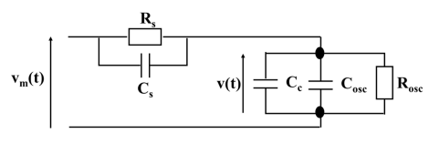

Rosc= 1 MΩ, Cc = 100 pF and Cosc = 20 pF

Preliminary calculations :
1) Calculate the ratio V/Vm

(1)

With
Z1= Rs//Cs ;

Z2=Cc//Cosc//Rosc

2) Find the condition for this ratio to be constant regardless of the frequency
In order to get a constant ration independent from the frequency
Z1 and Z2 have to be pure real with no phases
So we eliminate the imaginary part of these impedance in the ration calculation so we obtain

3) We want this ratio to be equal to 1⁄10, what value should take Rs in this case. Deduct the value of Cs.
If V/Vm= 1/10
We got

Then
;

We can also say that
Z1= 9*Z2

let’s replace Rs by its values in the equation above

We obtain

Numerical Application
Rs= 9 MΩ ; Cs= 13.33 pF

LT-Spice simulations :
1) Illustrate the previous calculation by simulating the circuit under LT-Spice
We start by drawing the electrical circuit with the real value

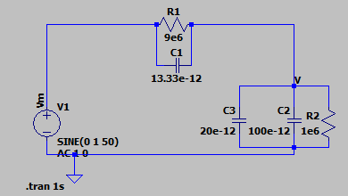

Afterward we make the simulation
- the AC simulation at f= 50Hz
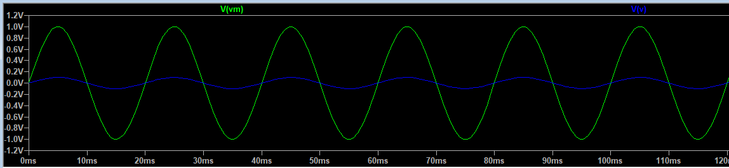

This simulation show us the accuracy of our calculation because we see well that we have Vm(t)=10 V(t) at each time

Let’s check the result with f= 20Hz

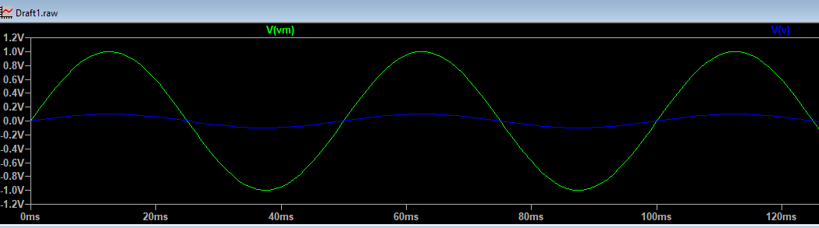

we observe again that the ration has not changed 1/10
that’s mean that the ration is constant regardless the frequency

- DC simulation

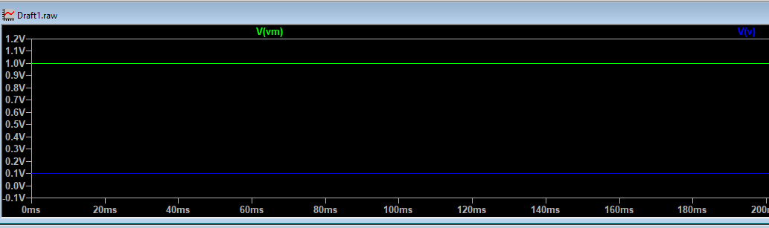

The ratio (Vm/V)constant is also valid for the DC simulation

2) Using a time dependent simulation, explain and clarify how the circuit behaves when the condition of a constant V/Vm ratio is not verified

if the ration between V scope and V to be measured is not constant that’s mean we consider the imaginary part

Simulation with Rs= 50 ohm and f = 50e5

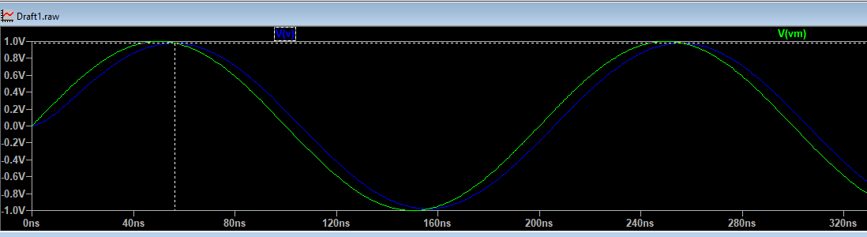

almost no attenuation we have also a phase shift

With F = 50e8

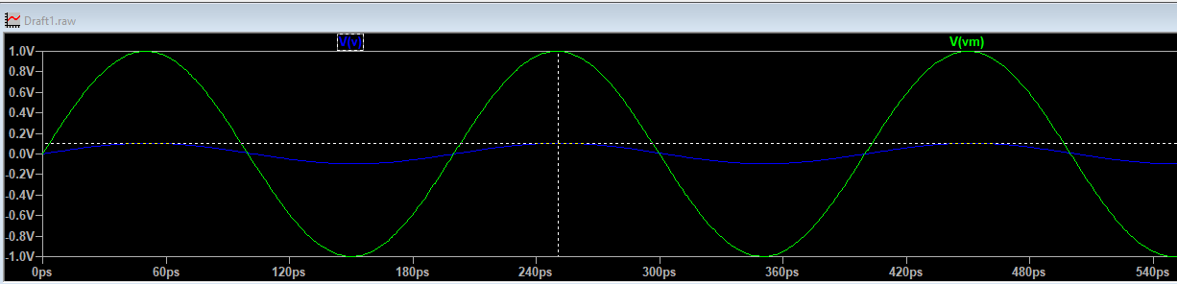

we observe that the attenuation depends on the frequency because by changing the frequency we have also change the amplitudes of V(t)

Conclusion:
When the condition of a constant Vmeasured/Vscope ratio is not met in the context of an oscilloscope probe, it means that the probe doesn't accurately represent the input signal on the oscilloscope screen. This condition is important because it ensures that the displayed waveform accurately reflects the actual waveform under test. When the condition is not met, it can result in various issues and inaccuracies as :
Amplitude variations
Phase shifts
Measurement Error

Problem 2 : Filter
Introduction:
In this part we are dealing with an active filter (the operational amplifier)
we are going to find the characteristics of such circuit circuit and understand is utility by hand calculation and also with LTSpice
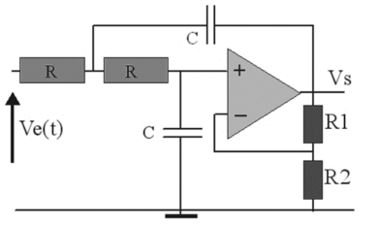
Preliminary calculations :
1) demonstration of the formula of the transmittance
(see handwritten PDF file joined)

K=(R2+R1)/R2
x=W/Wo
Wo= 1/RC

2) What type of filter is obtained
if W<Wo
we obtain x<<1

H(jw)= K

if W>Wo
we obtain x>>1
H(jw)= 0
From these calculs we can deduce that here we have a pass low filter

LT-Spice simulations :
1) We suppose that the operational amplifier is perfect. Discuss the behaviour of the Bode diagram in magnitude and phase as a function of the parameter K
We start by drawing the electrical circuit with the real value

For R=2.2k; C=15nF; R1=1k; R2=4.5k

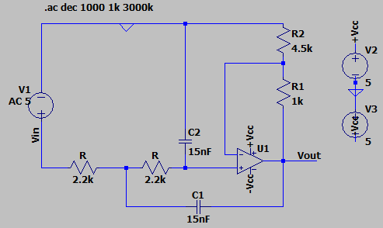
- Bode diagram
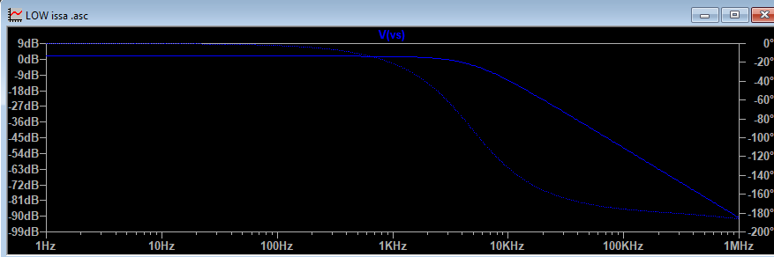

The bode diagram show us the nature of the filter (Low pass Filter)
we have no signal for greater frequencies
the input magnitude is 1.74dB it is find by Vs (dB)= 20log(K)
the input phase is 0° and the output phase at -180°
- Cut off frequency
Let determine the right value of Fc
it’s the frequency find at Vs max in dB-3dB
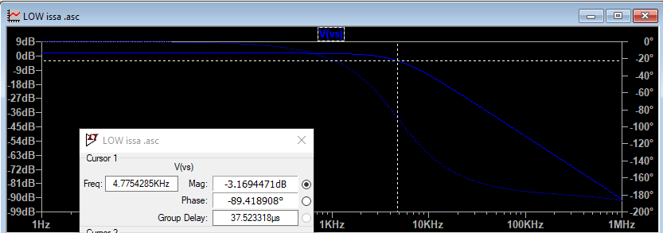

So we obtain Fc= 4.77 KHz and the phase is -90°
- Simulation with different value of K
- Let’s increase the value of K to see the difference
K= (R2+R1)/R2
Consider R1 = 5k
K<3
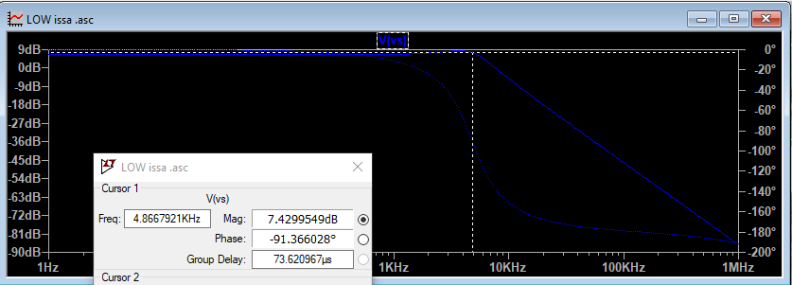
we can notice that the magnitude got higher so by changing K we change the magnitude of Vs which totally normal according to the equations
we observe a little magnitude peak due to the resonance in the cut-off region

Consider R1 = 10k
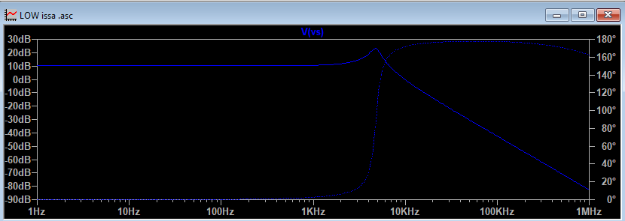
We can now notice that the phase has completely changed and became positive
that is due to the value of K. Because if we recall as the expression of transmittace is 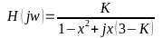
phase= - artan[x(3-K)/(1-x^2)]

when K>3 ; the phase become positive, we have a greater phase shift
we also observe a higher resonance peak than previously in the cut off region
Consider R1= 9k so that K=3
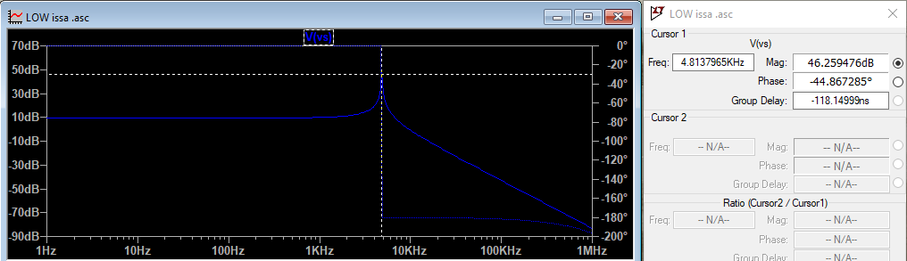
we observe the highest peak level and the phase change is very speed

2) What happens if you take into account the actual characteristics of the operational amplifier ?
If we consider a real OP Amp our equations are not anymore valid because V+ is not V-
For OP749

Consider R= 1k
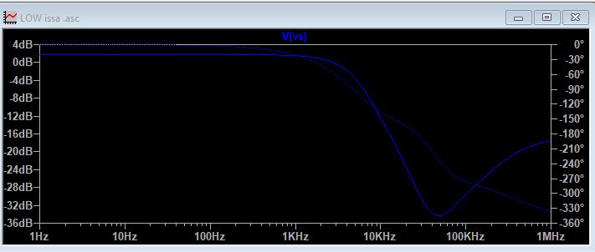

Consider R=5k

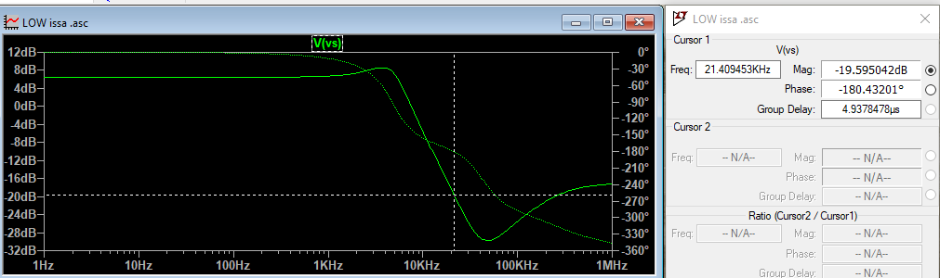

we observe that our previous calculation is only valid for a limited bandwidth from 1 to 20kHz
over this bandwidth filter do not realize the working required

Conclusion
In conclusion, the behavior of this second order low pass filter in the Bode diagram, both in terms of magnitude and phase, is strongly influenced by the parameter K. With a perfect operational amplifier, the system exhibits interesting responses, including resonance peaks and phase shifts. However, When considering the actual characteristics of the operational amplifier, the filter's performance deviate from the ideal behavior due to limitations in bandwidth and non-ideal characteristics of the op-amp. These deviations can affect both the magnitude and phase of the filter response

